Name: V.Siri Chandana
Roll No:2520030609
Section:2
Subject:DBSE&DBD
WEEK 9
HOMEPAGE:
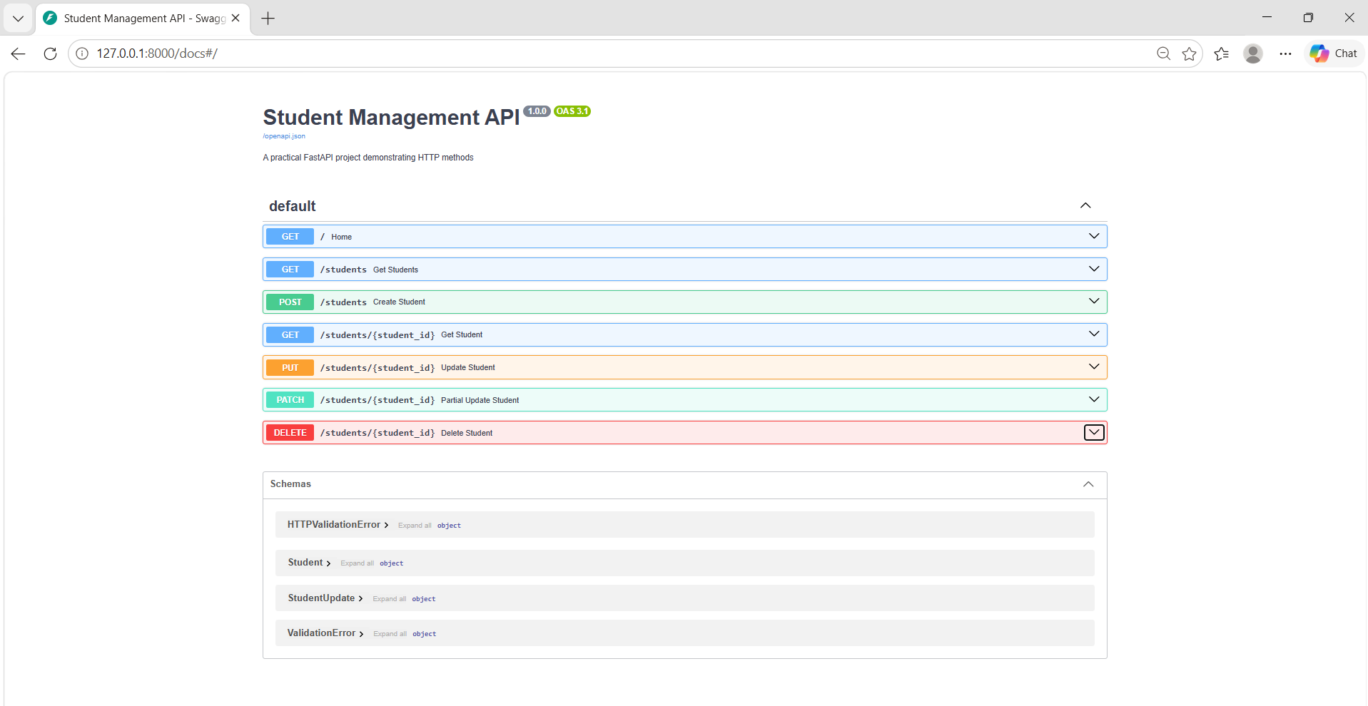
1.GET / Home:
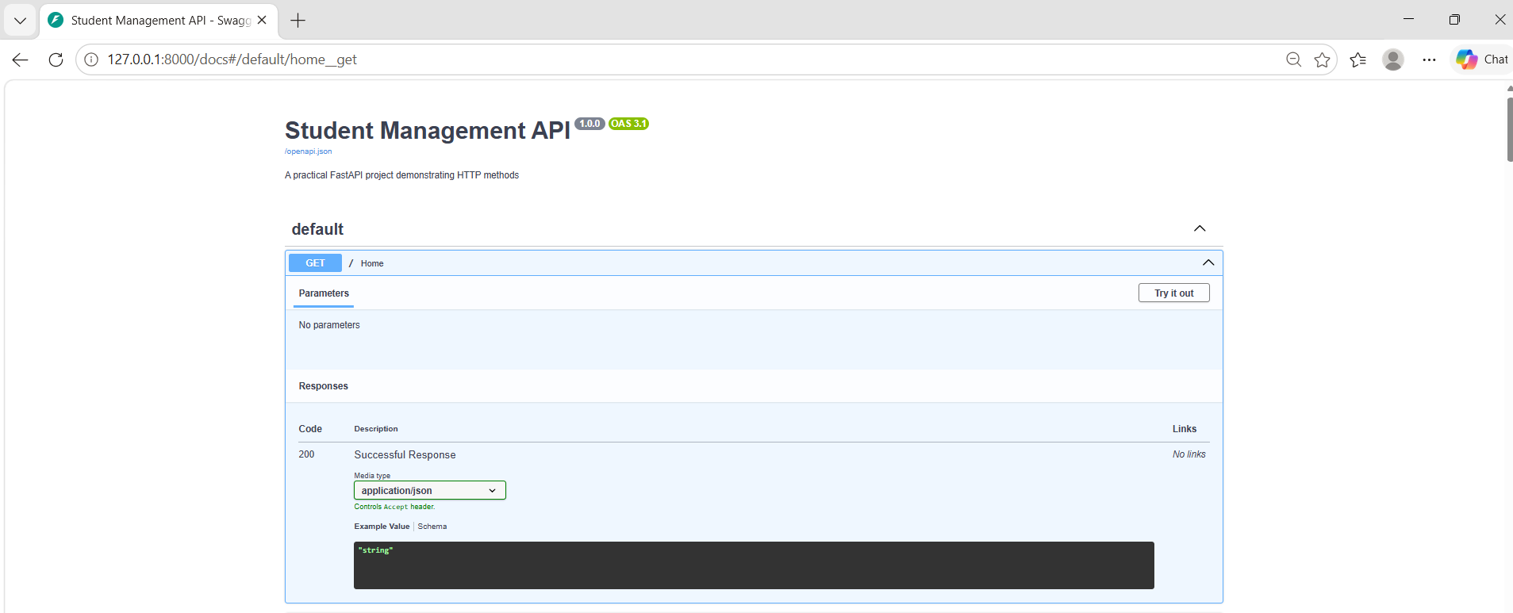

2. GET / students Get Students:
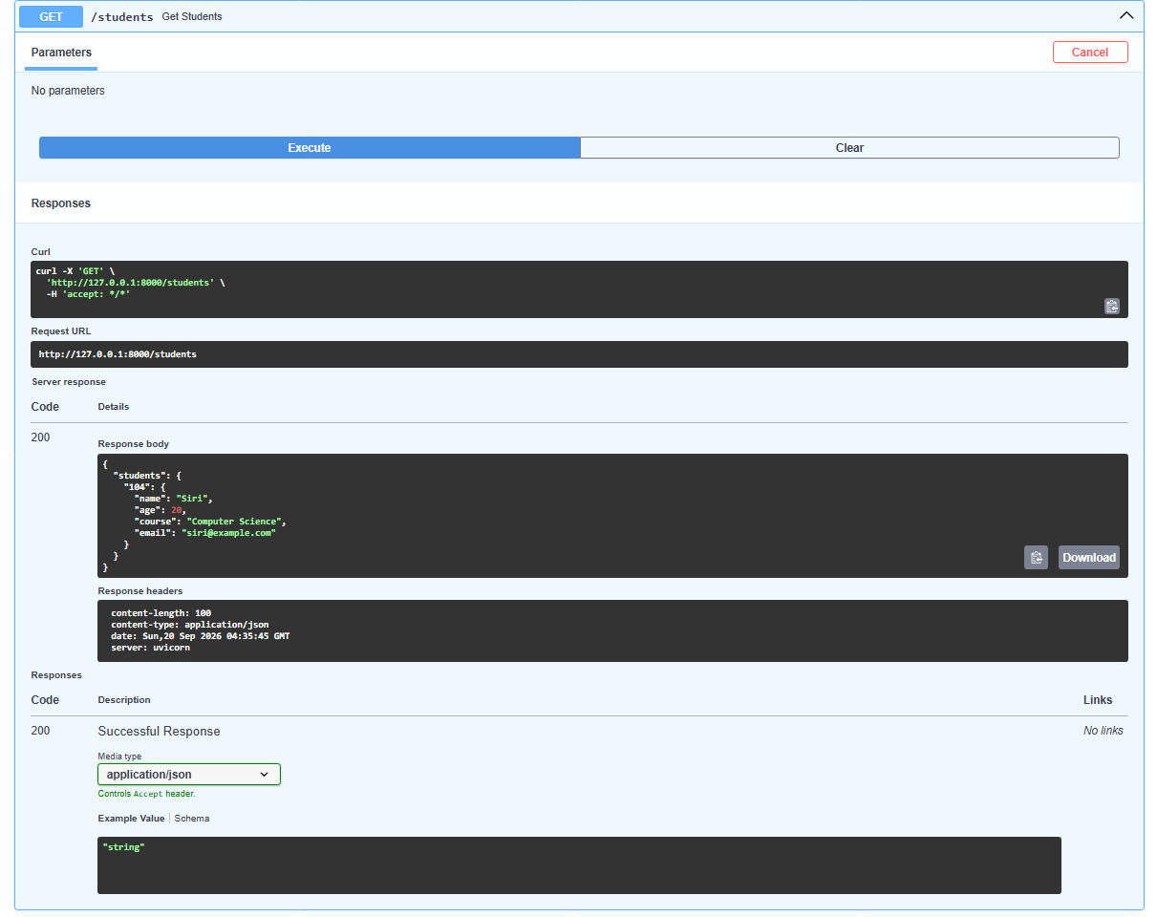

3.POST /students Create Student:

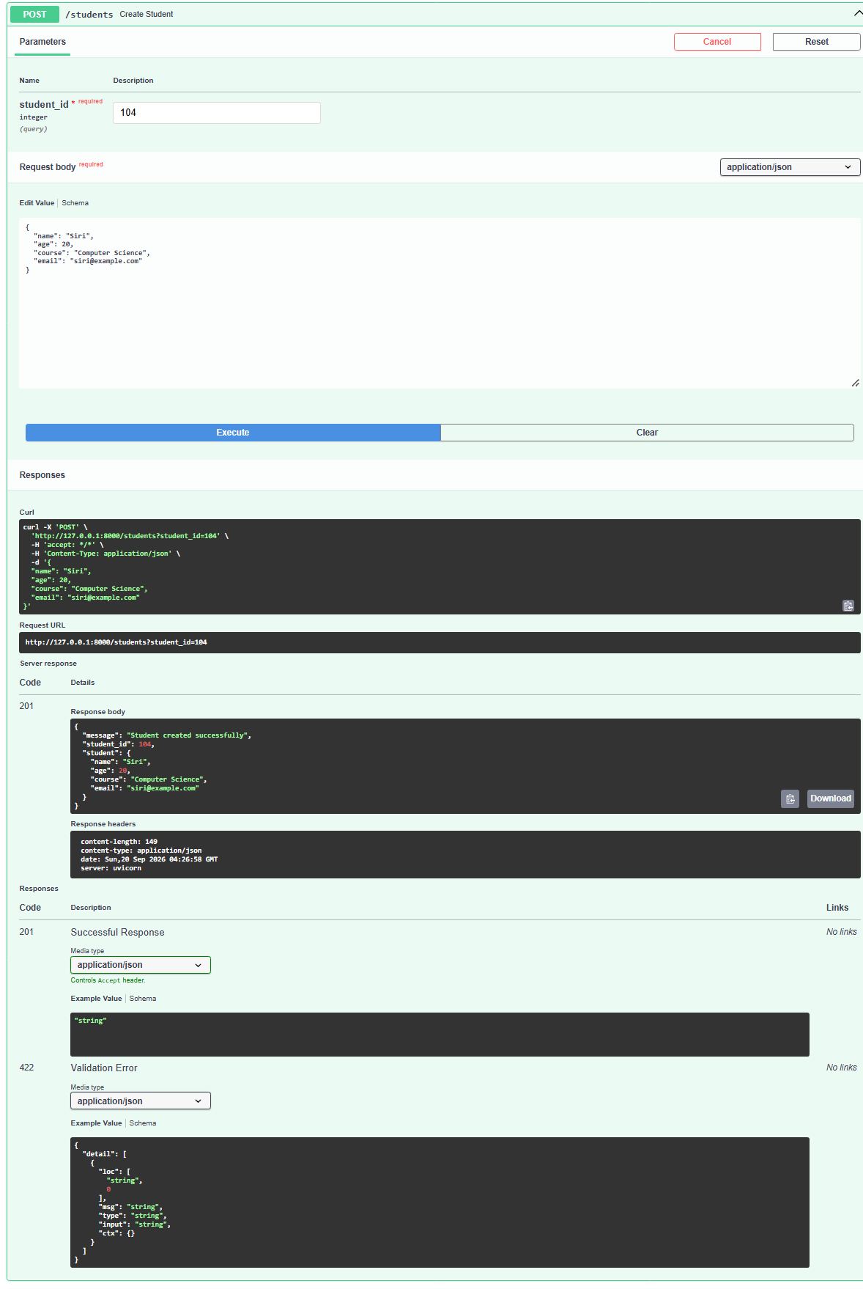
4. GET / students / {student_id} Get Student:
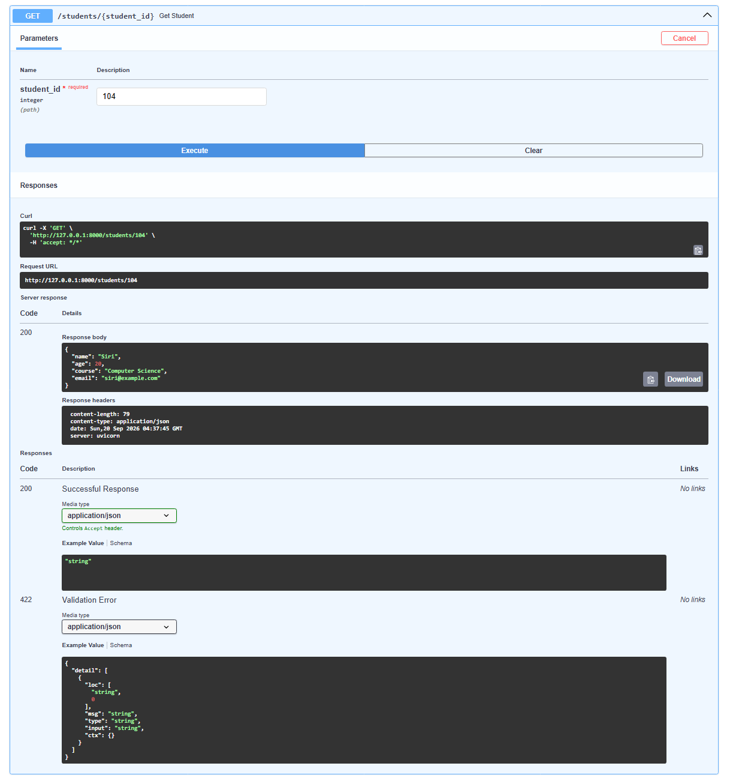

5. PUT / students / {student_id} Update Student:
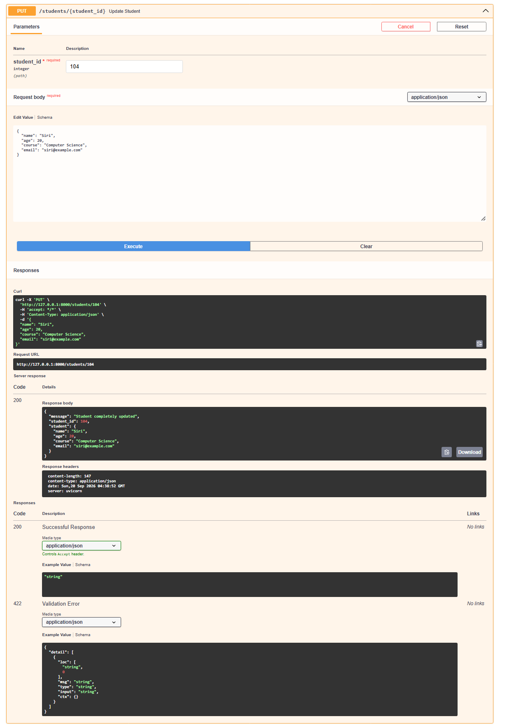
6. PATCH / students / {student_id} Partial Update Student:
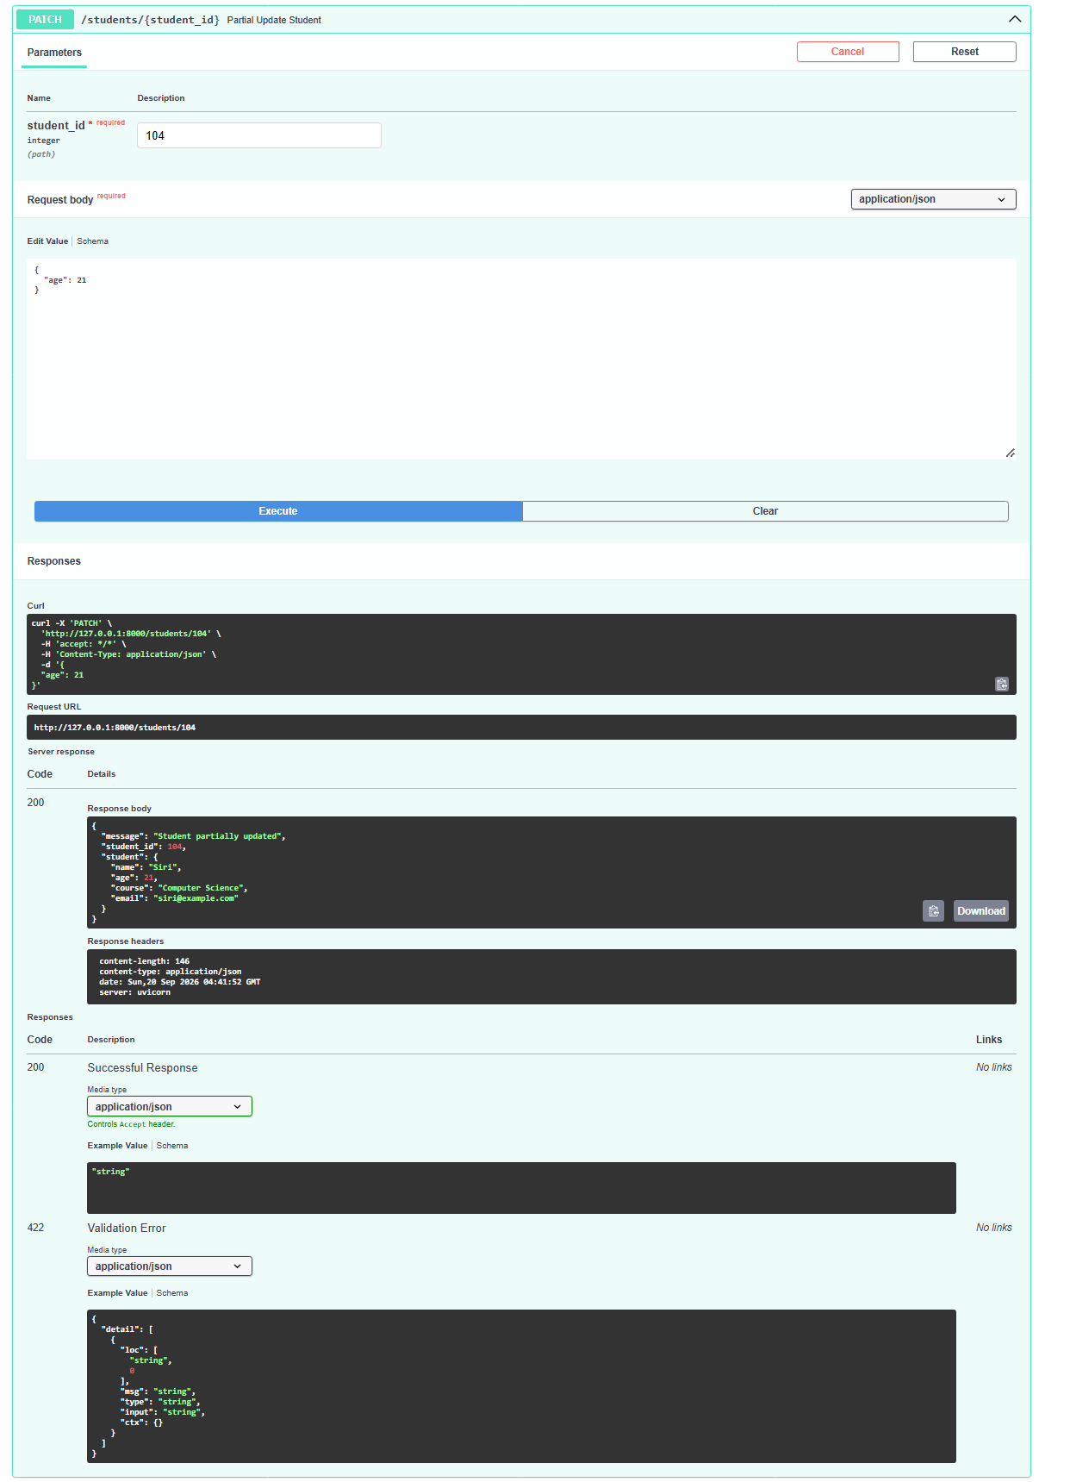
7. DELETE / students / {student_id} Delete Student:
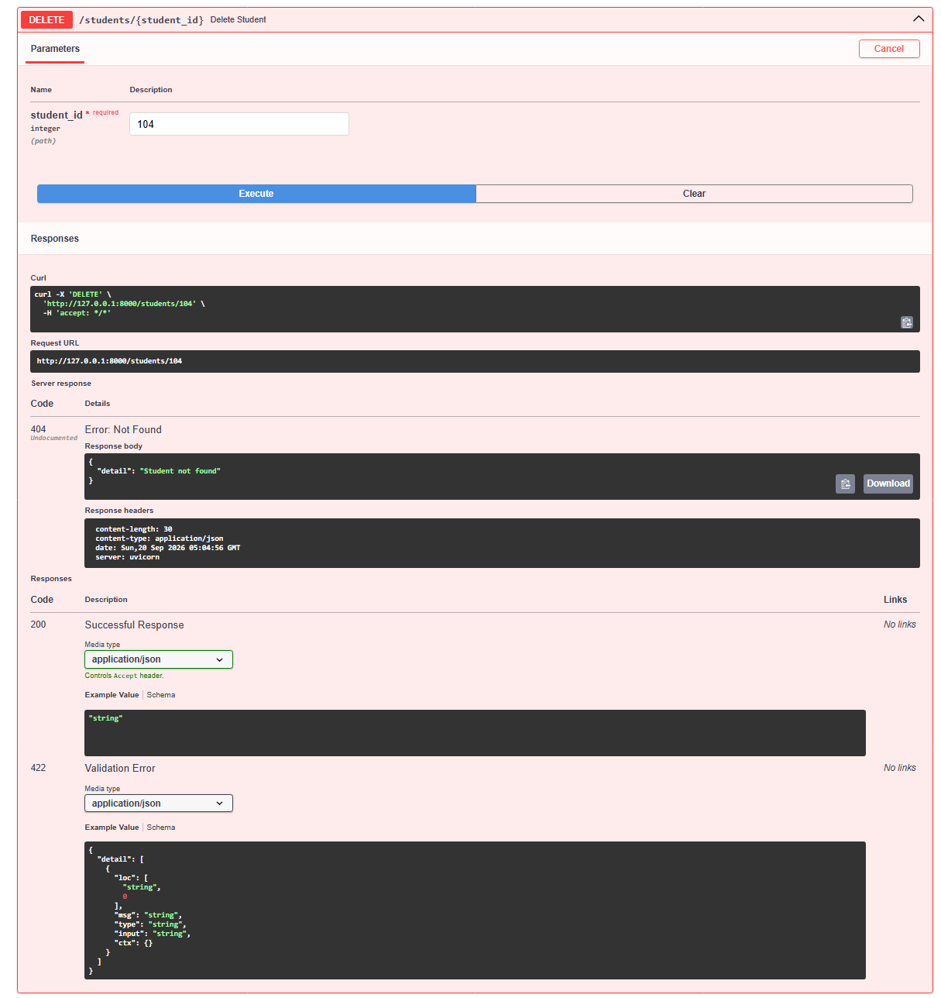

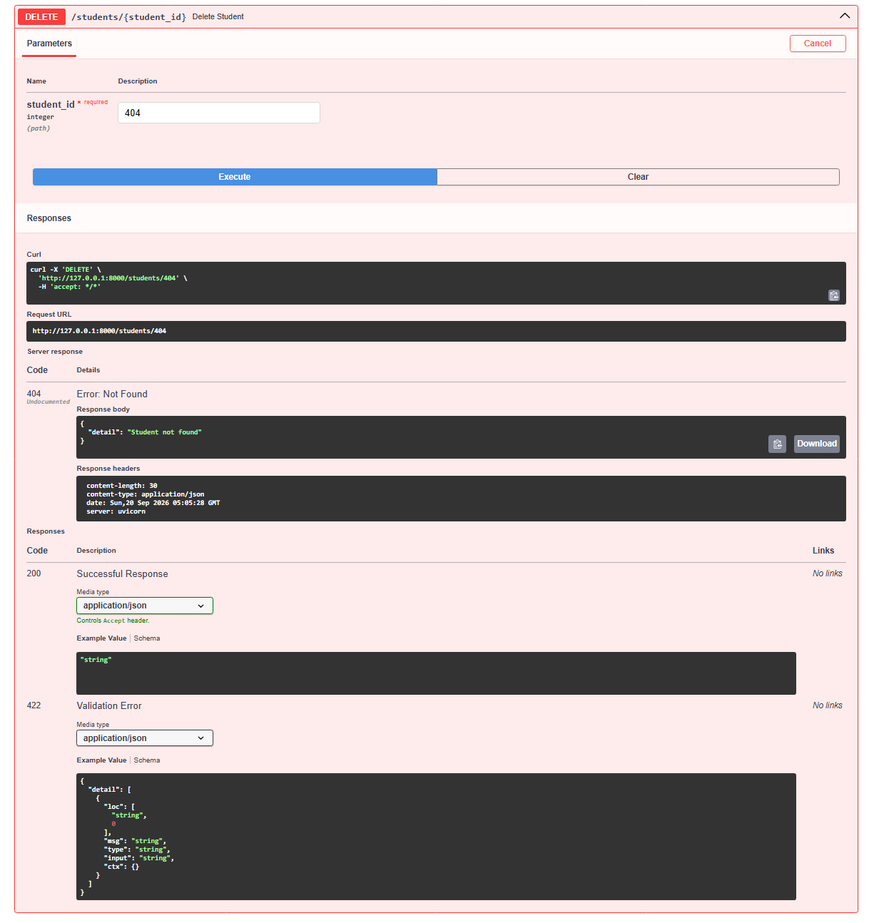

HOMEPAGE:
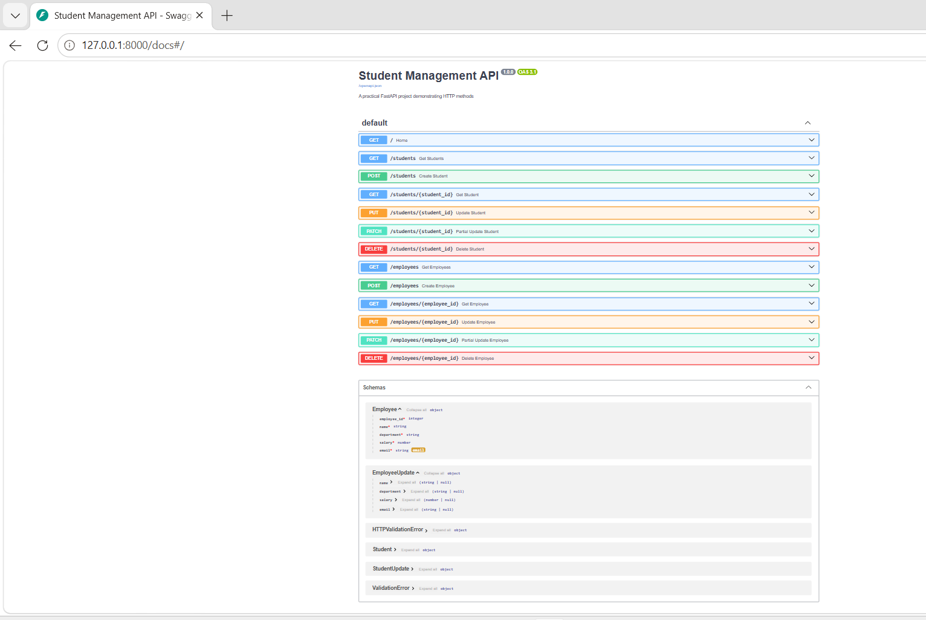

1. GET / employees Get Employees:

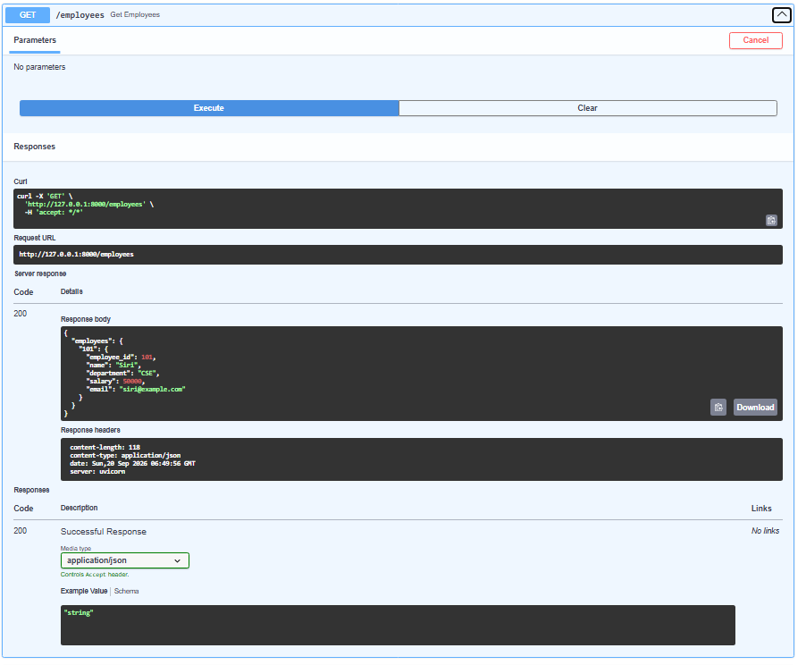
2. POST / employees Create Employee:
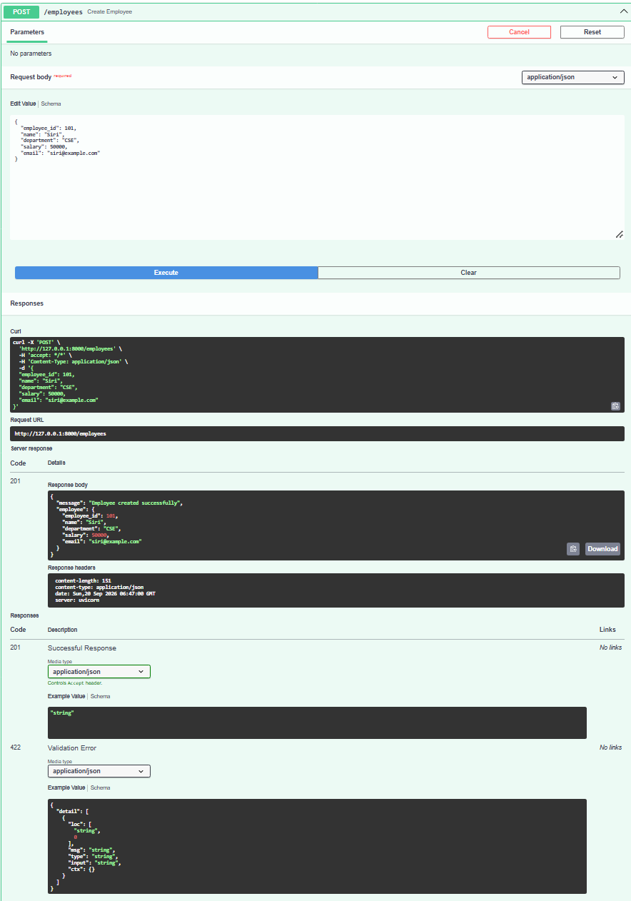
3.GET / employees / {employee_id} Get Employee:
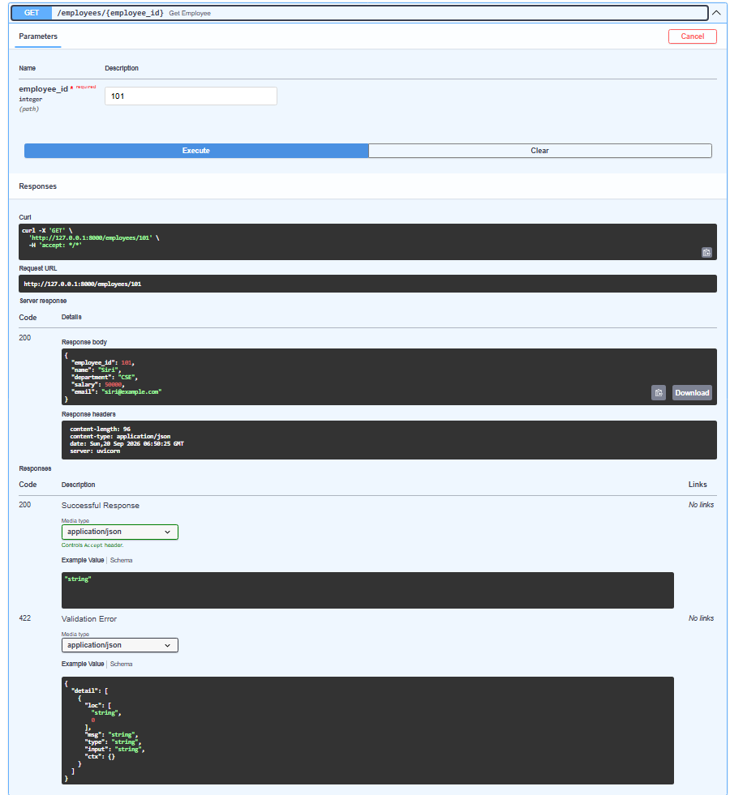
4.PUT / employees / {employee_id} Update Employee:
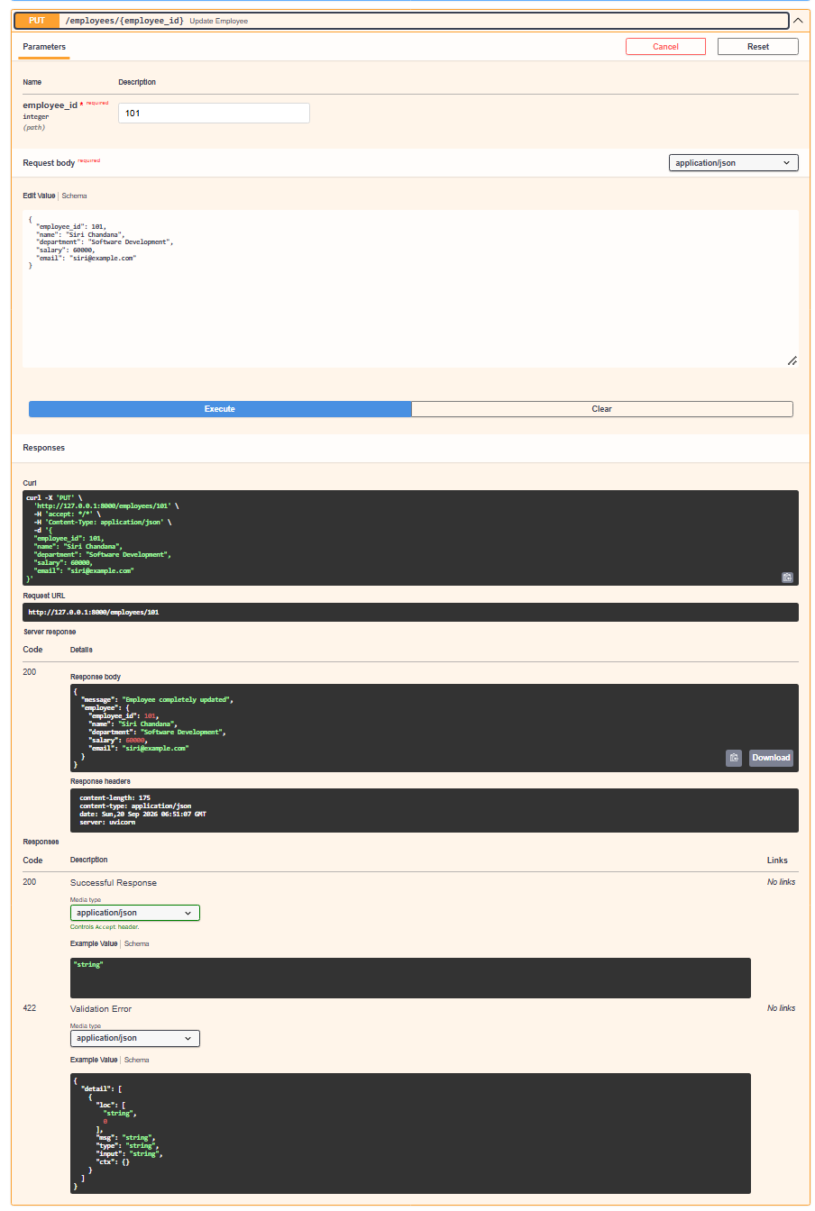
5.PATCH / employees / {employee_id} Partial Update Employee:
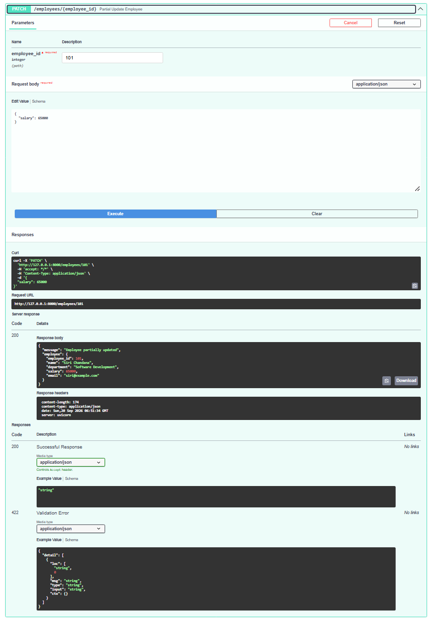
6.DELETE / employees / {employee_id} Delete Employee:
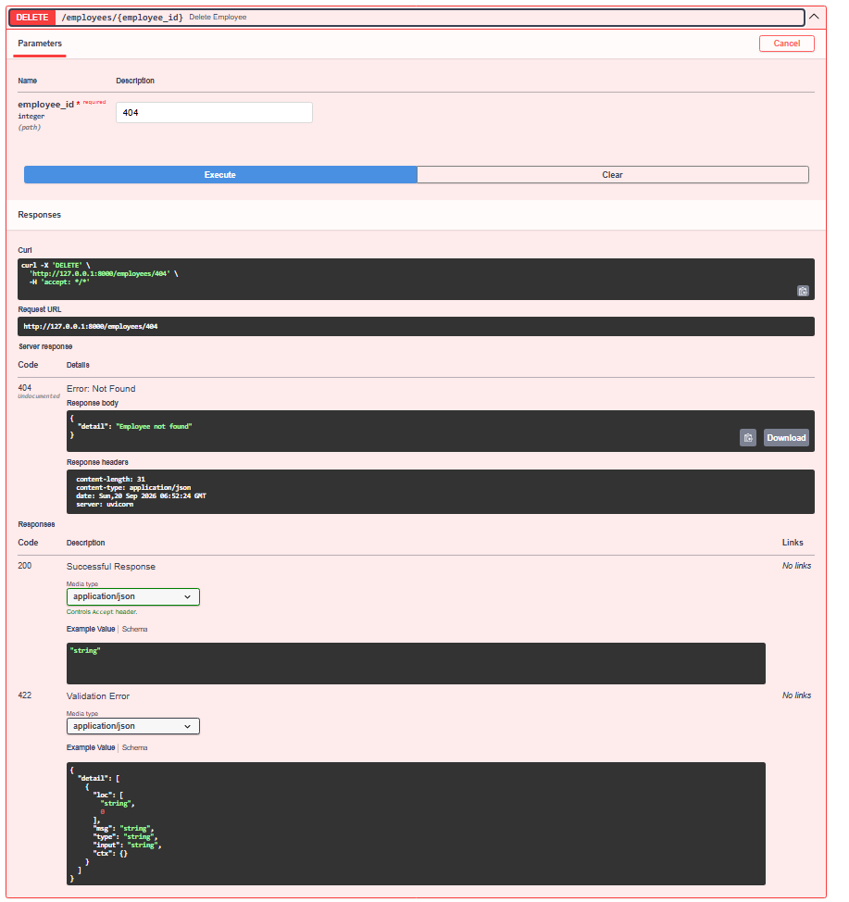

Schemas:
